INTERNATIONAL SOCIETY FOR ASPHALT PAVEMENTS
BIOGRAPHICAL SKETCHES OF NOMINEES FOR
OFFICERS FOR 2017

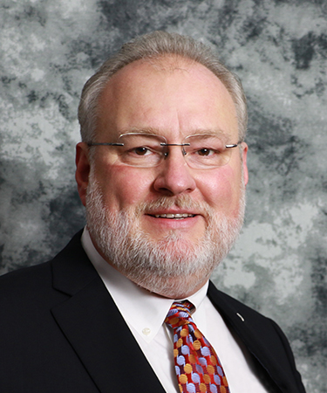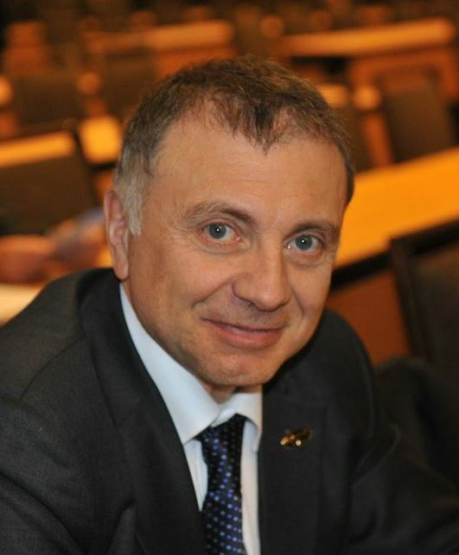NOMINEES FOR OFFICERS (Three to be elected)
Gaylon L. BAUMGARDNER
Senior Vice President, Ergon Asphalt and Emulsions, Inc., a subsidiary of Ergon, Inc. and Executive Vice President of Paragon Technical Services, Inc. both of Jackson, MS. He has thirty-five (35) plus years of experience in the petroleum and petroleum related products industries with strong ties to asphalt and asphalt related products and systems. Baumgardner holds a BS in Chemistry from Henderson State University and PhD in Civil Engineering from Mississippi State University.
Prior to employment by Ergon, Inc. in 1988, Dr. Baumgardner served as Manager of Technical Development for Siplast, Inc., a producer of commercial modified bitumen roofing systems, a division of Elf Aquitaine at the time, later owned by the ICOPAL group, now GAF Materials Corporation. Currently under his direction, Paragon Technical Services, Inc., (PTSi) is responsible for research and development services for Ergon Asphalt and Emulsions, Inc. and Ergon Armor, Inc. with primary focus in paving and related products, which include asphalt, polymer modified asphalt, asphalt emulsions, and polymer modified asphalt emulsions as well as specialty coatings. He also oversees full-service third party testing and development capabilities offered by PTSi to the petroleum refining, roofing, waterproofing, protective coatings, specialty asphalts and asphalt paving industries.

Baumgardner is an active member of the Association of Asphalt Paving Technologists (AAPT) (current First Vice President), the Association of Modified Asphalt Producers (AMAP) (past president), the Canadian Technical Asphalt Association (CTAA) and the International Society for Asphalt Pavements (ISAP). He presently serves on various task groups for the American Society for Testing and Materials (ASTM) D04 and D08, has served as Chairman for the International Technical Committee of the Asphalt Emulsion Manufacturers Association (AEMA) and the organizing committee for the International Symposium of Asphalt Emulsion Technology (ISAET), has served as Chairman of the Asphalt Institute Technical Advisory Committee (TAC) and Roofing Technical Advisory Committee (RTAC) (current chair), serves on the board of directors of the International Bitumen Emulsion Federation (IBEF), currently serves as Co-Chairman of Binder Expert Task Group and as a friend of the National Center for Asphalt Technology (NCAT) Applications Steering Committee, a member of the Pacific Coast Conference on Asphalt Specifications (PCCAS), member and board member of the Southeastern Asphalt User/Producer Group (SEAUPG), also serves as an active member of the American Chemical Society (ACS) as well as other technical committees in the asphalt and petroleum products industries.

Hervé DI BENEDETTO
Professor, University of Lyon/ENTPE, herve.dibenedetto@entpe.fr
Professor Hervé Di Benedetto received his Diploma of Civil Engineer from the "Ecole Nationale des TPE" (ENTPE, University of Lyon) and his PhD from the University of Grenoble, France.

Currently he is Professor at ENTPE, University of Lyon. He is also, since 2011, visiting Professor at the University of Quebec (ETS). He is member of “Laboratoire de Tribologie & Dynamique des Systèmes” (LTDS, UMR CNRS 5513) where he is leading the team “Geomaterials and Sustainable Constructions”.

Prof. Di Benedetto’s research activities focus on the study of mechanical, thermo-mechanical and structural behaviour of geomaterials and infrastructures, including experimental, simulation and modelling aspects. He is working in the fields of road engineering and soil mechanics.
He has been the supervisor of about 50 PhD students and many research projects. He is the author of more than 200 publications. He is Editor-in-Chief of the International Journal “Road Materials and Pavement Design” (http://www.tandfonline.com/loi/trmp20).

Professor Di Benedetto is a well know expert, which is frequently invited or keynote speaker for international conferences. Among others, he delivered in 2015 the 3rd prestigious Bishop Lecture of the Int. Soc. of Soil Mechanics and Geotechnical Eng. (ISSMGE).

He is past President of International Society of Asphalt Pavement (President of ISAP from 2013 to 2015), and is co-founder and member of the Steering Committee of the European Asphalt Technology Association (EATA). He Chaired Technical Committee 101 of the International Society of Soil Mechanics and Geotechnical Engineering (ISSMGE) from 2009 to 2013. He was from 2009 to 2014 international representative of the Board of the Association of Asphalt Pavement Technologists (AAPT). He is a Fellow and member of the Technical Advisory Committee of “International union of laboratories and experts in construction materials, systems and structures” (RILEM) in charge since 2014 of cluster F “Bituminous Materials and Polymers”.

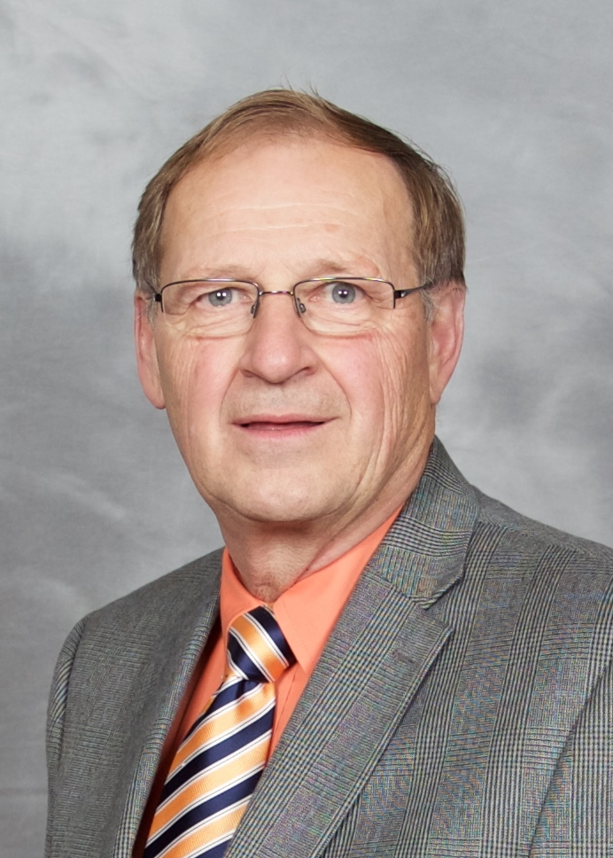Gerald HUBER
Gerald A. Huber is a native of Balgonie, Saskatchewan, Canada where he became a pilot in high school and served Canada by joining and serving in the Royal Canadian Air Force. He graduated from the University of Saskatchewan with Great Distinction with a Bachelor of Science Degree in Civil Engineering. Following graduation, he began a 10-year term with the Saskatchewan Highways and Transportation where he was active in asphalt technology including supervision of asphalt pavement construction, development of specifications for paving in cold weather and asphalt pavement design. Gerry then received his Master of Science degree in civil engineering at The University of Texas at Austin where he studied and worked under the supervision of Dr. Thomas Kennedy and Dr. Freddy Roberts. His research involved the investigating the effect of missing temperature and moisture content in asphalt concrete mixes.

In 1988, Gerry joined the Asphalt Institute as a district engineer for the Minneapolis office. He then transferred to the Institute’s Headquarters in Lexington, Kentucky as the Associate Director of Research. He developed, managed and presented research products involving asphalt materials. He was also the Institute’s principal contributor to the research efforts of the Strategic Highway Research Program where he was one of the key players in the development of the Superpave gyratory compactor and many of the mix design parameters that remain in use in the Superpave system.

In 1992, Gerry left the Institute for his current position as the Associate Director of Research at the Heritage Research Group. In this role, he develops and executes internal and sponsored research project and provides technical representation for Heritage and its many affiliates nationally and internationally.

In addition to serving on the ISAP board, including being the Chair, for many years, he has held a leadership role in many other related organizations. He has served on the board and been President of both CTAA and AAPT and been an active member of ASTM and ASCE. He served as Chair of TRB’s Committee for Flexible Pavement Construction and Rehabilitation. Gerry has also been a member of and/or chaired numerous other professional groups. He has published over 30 journal articles and has averaged a remarkable one asphalt technology journal paper per year.

Yiqiu TAN

Photo and biographical sketch not available.

Adam ZOFKA
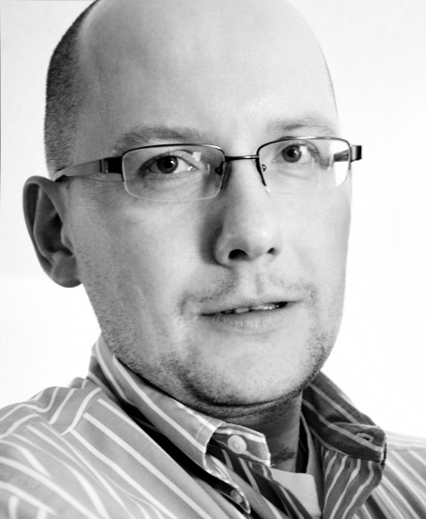 International expert in transport infrastructure studies; concrete and asphalt structures; 10-year experience in USA, 5 years in Europe; cooperation with TRL (UK), TNO (Netherlands), IFSTTAR (France), FHWA (USA), BASt (Germany), ARRB (Australia), BRRC (Belgium), and others; airport and roadway pavement design and condition assessment, pavement mechanics, computational techniques, development of advanced materials and devices (Advanced Shear Tester), tire-pavement interaction, non-destructive evaluation (becats.eu), spectroscopic methods (SHRP2 project), advanced statistics; good presentation and communication skills; enthusiastic supervisor and teacher; presentations at 70+ conferences in USA, Europe and Australia; author or co-author of 100+ publications and reports; active member of international professional organizations (TRB, RILEM, ASCE, AAPT, ISAP); deputy chair for TRA2016 conference – largest transport-oriented conference in Europe; experience in working with private and governmental agencies in USA and across Europe, and with European Commission.

